
Discovery Software Ltd

Dynamic Software Solutions

NineNil Manual
Squash League Management System
NineNil Manual
© Discovery Software Ltd
www.discoverysoftware.co.uk
36 Elm Park, Paignton, Devon, TQ3 3QQ, United Kingdom
Phone +44 (0)1803 663975
Email info@discoverysoftware.co.uk

Table of Contents

Setting up NineNil 1
How to Get Started 1
Setting Up Your League 3
Divisions 3
Clubs 5
Teams 6
Players 7
League Options 8
Dates to Avoid 10
Creating Fixtures 11
Checking for Fixture Conflicts 13
Running Your League 15
Team Captains 15
Entering Scores 16
Checking Player Eligibility 18
Adding Players 19
Club Administrator 20
League Secretary 21
Messages 21
Penalties 22
World View of League 23
Fixtures and score cards 23
Division Tables 25
Player Statistics 26
Player Registration Lists 27

Chapter
1

Setting up NineNil
What is NineNil and how do I get started?
NineNil is a complete on-line squash league management system designed by players for players. It enables the organisation of the leagues to be conducted on-line via the Internet. NineNil automates the workload traditionally completed by the league organisers.
NineNil provides access to fixtures lists, results, verified score cards, divisional tables, player ranking lists and player statistics. It can be viewed by teams, members, other clubs and the squash world.
For the participating clubs and teams, it is a secure password protected system providing access to league set-up features, player rankings lists and score cards.

How to Get Started
When you purchase NineNil, Discovery Software will set up an entry on the Discovery Software website for your squash league or association. By default, the league will be set up with a number of values relating to the start and end of the season and the rules that are to be used with your league. In the examples that follow we will be setting up and using a league for a fictional county called Cameronshire.
To get to this new league we must first navigate to the NineNil Associations page within your Internet browser. In the address bar of your browser type in:
http://www.discoverysoftware.co.uk/NineNilAssocs.asp.
You will see a list of available leagues or associations.
Please note that you must have cookies and JavaScript enabled in your browser for NineNil to work correctly.
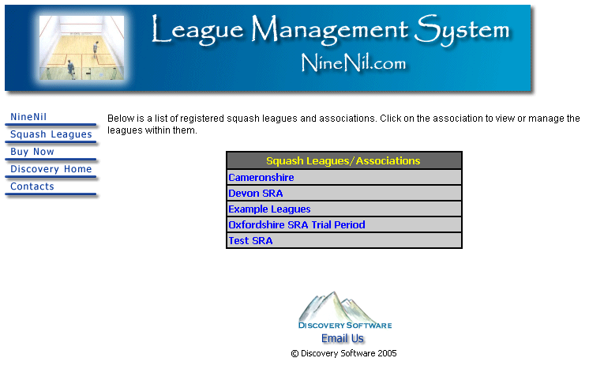
Figure 1 - List of existing squash leagues/associations
Click on the appropriate link to proceed to your league/association. Please note that an association can have any number of leagues, for example, a Mixed League, a Ladies League and a Juniors League. Each of these will be set up separately by Discovery Software.
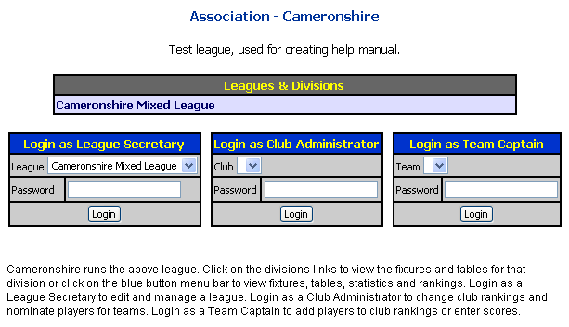
Figure 2 - Access to leagues and login screen for NineNil 'roles'
Discovery Software will provide you an initial password with which you can log onto your league as League Secretary for the first time (or until you change the password). There are three ‘roles’ within NineNil, the League Secretary who has full access to all League set up and running options, the Club Administrator who can maintain Player Registration Lists (Rankings) and fill out score cards, and the Team Captain who can add players to Player Registration Lists and fill out score cards. We will explore the latter two roles later in the manual but for now you should type in the password you have been given in the League Secretary password textbox and click on the Login button.

Setting Up Your League

Once you have logged on as the League Secretary you will be presented with the various league setup options in addition to the functions needed to manage your league while it is running during the season.
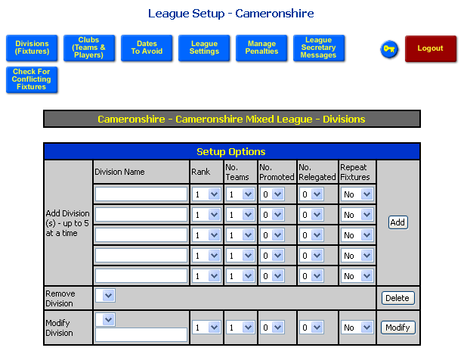
Figure 3 - League Secretary options and divisions entry form
The figure above illustrates the options available to the League Secretary. These are accessed by clicking on the blue and red buttons. Each of these options will be discussed within this chapter.

Divisions
The first screen you will see will be the Division entry form. Here, you can add, modify or delete Divisions from your league. You can add up to five divisions at a time using this form. Figure 4 shows how to add four new Divisions called ‘Premier Division’, ‘Division 1’, ‘Division 2 South’ and ‘Division 2 North’. Use the rank drop-down lists to define the relative order of the Divisions. In this example, the Premier League is the top league so it has a ranking of 1. Division 1 is the next highest, so it has a rank of 2. There are two Division 2 divisions, North and South. Each has the same rank of 3.
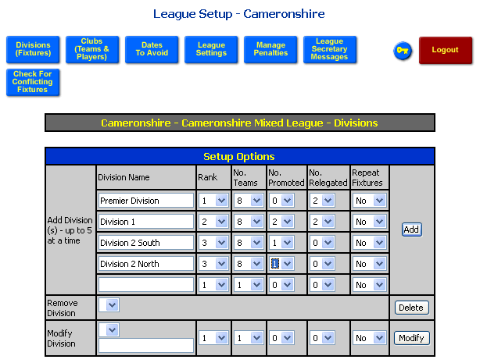
Figure 4 - Adding four new divisions
You should also specify the number of teams in each Division and how many teams are promoted and relegated at the end of the season. The final option is to define whether the fixtures are to be repeated in the Division. For example, if your league had a small premier division you may wish to repeat all of the home and away fixtures to so that each team plays every other team four times in a season.
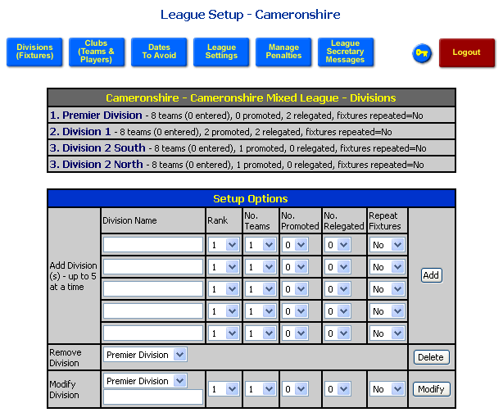
Figure 5 - Added divisions
Once you have added some divisions you will see that they are now listed under the Divisions table. You can also now delete a Division by selecting the Division from the Remove Division drop-down list and then clicking on the Delete button. To modify a Division, select the Division from the Modify Division drop-down list and then edit the options that you wish to modify. You can change the name of the Division by entering the new name in the textbox below the drop-down list. Once you have changed the items you wish to modify, click on the Modify button to save the changes.
The following section describes how you can add clubs and teams to your league. When you have assigned the appropriate number of teams to each Division you will notice that the Division entry form also allows you create, view and clear fixtures for each Division and to check the fixtures for any potential conflicts. This will be described in the Create Fixtures section.

Clubs
To access the Clubs page click on the ‘Clubs (Teams & Players)’ blue button. The Clubs entry page works in the same way as the Divisions entry page, with five addition rows and remove and modify options.
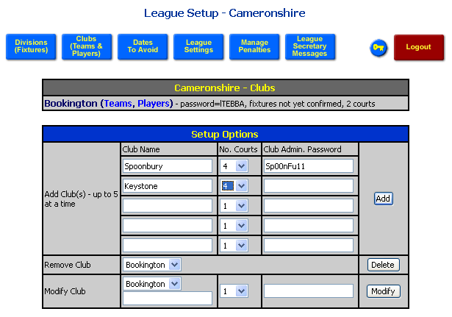
Figure 6 - Adding, removing and modifying Clubs
The figure above shows one Club (Bookington) already added and the additions of two new Clubs (Spoonbury and Keystone). The options for a new Club include the name, the number of courts available at that club and the password for the Club Administrator. The number of courts is used when checking for possible fixture conflicts. This process assumes that each fixture requires two courts. Therefore, if a club has 3 teams playing at home on a particular day but only has 4 courts, this will register as a conflict. The League Secretary would then manually change one of the fixtures to another day.
If you leave the password textbox empty then NineNil will automatically create a password for you using a random selection of upper and lowercase characters. The League Secretary, Club Administrators and Team Captains can change their passwords at any time when they are logged on (see Chapter 2, Fugure 19).
When clubs are added to the system, links (adjacent to the club name) are provided to enable the addition of teams and players to those clubs (see in Figure 6, in brackets next to Bookington).

Teams
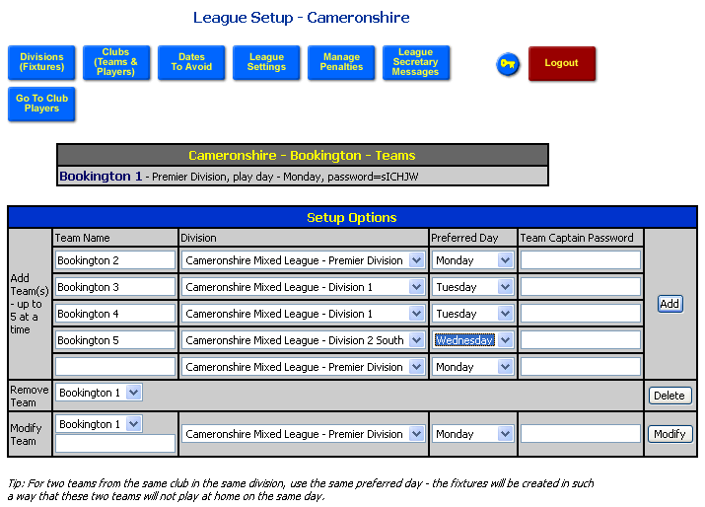
Figure 7 - Adding, removing and modifying Teams
Each club can have a number of Teams playing for it. Each Team may have it’s own name but would commonly be the club name followed by a number indicating its rank within the club. The figure above shows the addition of some Teams for the Bookington club. For each Team you should specify the Division that it is to play in for the upcoming season. You should also select the preferred day for playing home matches. This day is used when creating the fixtures. A useful tip is that if you have two teams from one club playing in the same division then you should select the same preferred day for these teams. This pairing will inform the fixture creation procedure that the two teams should not play at home on the same date.
As with the Club set up, if you leave the password textbox empty then NineNil will automatically create the password for you.
An additional blue button is displayed on the Team entry page. This allows you to go directly to the Players entry page for this club, rather than navigating via the club page again. Similarly, there is a blue button on the Players page providing a link back to the Team page.
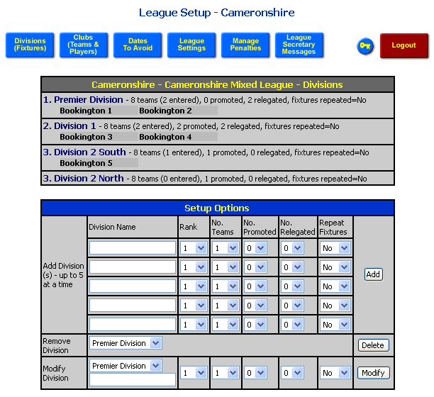
Figure 8 - Division view showing added teams
After adding teams to particular divisions, these teams will now appear on the Divisions entry page as shown above. This view lets you see how many and which teams have been added to each division.

Players
Adding Players is again similar to the previous items. Players should be placed in their rank order within their club. The rank is defined using the Rank drop-down list which allows you to place a Player at the bottom or top of the ranking list or above a previously entered named player. In the example shown in Figure 9, the first four players are added to the bottom of the ranking list in turn, while Neville Martins is added above Kevin Upton.
You can also use the Nominated Team drop-down list to assign or nominate a player to a team. Each team should have 5 players nominated to it before the season begins. These are the players that are expected to play for the team in every fixture (nominated players should play for the team at least 3 times in each half of the season). Players do not need to be nominated to a team. These players are still part of the rankings of the club and may be available to play for any team as substitutes. The string order of each nominated player is determined by their relative ranking within their team, i.e. the highest ranking nominated player for Bookington 1 will play at string 1, the next highest at string 2 and so on.
The Squash Membership Numbers and Telephone Numbers are optional entries and are provided simply for information if required.
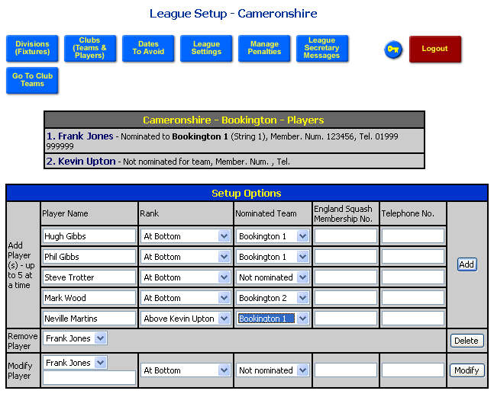
Figure 9 - Adding, removing and modifying players
As players are added the team entry page will be modified to show the players nominated per team, as shown below.
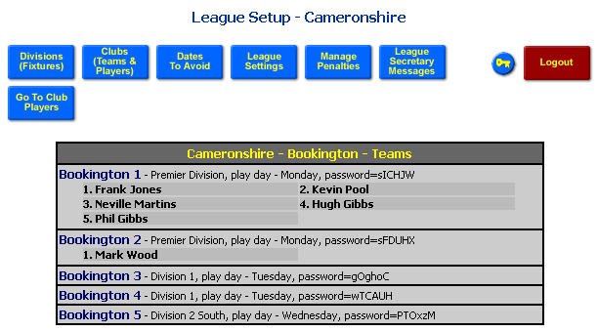
Figure 10 - Team view showing nominated players
As the League Secretary you can change ranking lists of any club as you wish. A Club Administrator can only change the ranking list for their own club and the times within which they can change nominations and ranking orders can be restricted to certain periods within the season.
Please note that it is normally the job of the Club Administrator to maintain the Player Registration Lists.

League Options
There are a number of options relating to the season dates and rules that are applied that can be altered by the League Secretary. Figure 11 shows the options that are available.
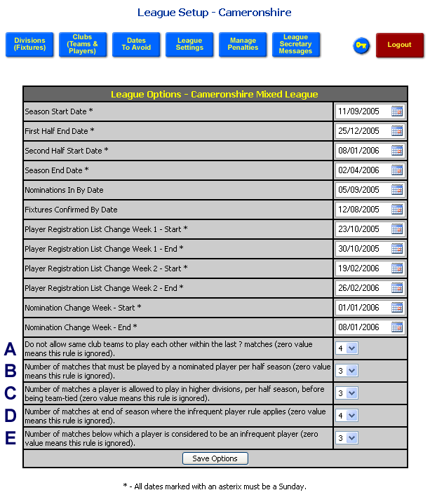
Figure 11 - League options
A typical season is split into two halves. Within each half all teams play each other once. The dates which define the two halves must always start on a Sunday as should other dates marked with an asterix (see Figure 11). These latter dates define periods in the season when Club Administrators can change ranking positions or change rankings and nominations. The two remaining dates relate to deadlines when nominated players should be registered and when fixtures should be agreed by. A one point per week or part week penalty is applied for late nominations and a five point per week or part week penalty is applied for late fixture confirmation.
To change a date you need to click on the calendar icon and then use the calendar tool that pops up as shown below.
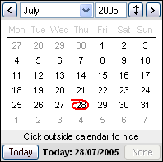
Figure 12 - Calendar pop up window
To insert a date you can change a month by clicking on the left or right buttons or select the month from the drop-down list. To change the year, click on the up or down arrow button. To finish, click on the date that you require.
The remaining options A – E relate to a number of rules that can be applied to your league.
- A – Place in here the number of weeks at the end of the season when teams from the same club are not allowed to play each other. Make the value zero if you do not wish to include this rule.
- B - Select the number of matches that each nominated player should play in each half of the season.
- C - Players can play for other teams from their club, in higher divisions. However, once they have played for other teams a certain number of times. They are not allowed to then play for the lower team. Select the number of times or zero if the rule is not required
- D and E - The final two options relate to the infrequent player rule, which is best described with an example. In the last 4 matches of the season players must have played for their team 3 times. Those satisfying this criteria play in order at the top string places in their team. Those not satisfying the criteria must play below those that do, but in their own relative ranking order. You should make both values equal to zero to not apply this rule or select a value in option D for the number of weeks and a value in E for the number of matches played.

Dates to Avoid
When creating fixtures for a season there may be periods during the season when you might not want fixtures, for example when teams are participating in cup weeks or when clubs have specials days such as Valentine’s Day. You can specify these periods in NineNil by clicking on the ‘Dates to Avoid’ blue button.
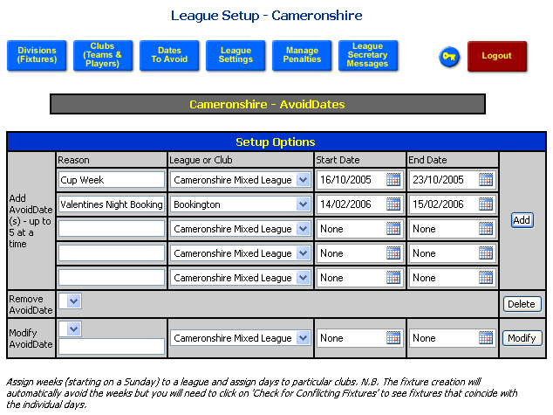
Figure 13 - Adding, removing and modifying dates to avoid
Any weeks that should be avoided by all teams should be assigned to the League using the ‘League or Club’ drop-down list. The dates for a week gap should start and end on a Sunday.
Single days for a particular club should be assigned to that club by selecting the club from the ‘League or Club’ drop-down list.
Please note that all specified weeks are automatically avoided by the automatic fixture creation process. However, the single club dates are not. You can check whether fixtures conflict with these dates by using the Check for conflicting fixtures blue button after you have created the fixtures.

Creating Fixtures
Once you have added all of the required divisions, teams, dates to avoid and league dates you are ready to create the fixtures for the league. On the Divisions page you will now see ‘Create Fixtures’ links as shown in Figure 14. Clicking on these links will initiate the fixture creation and the resulting page will show the fixtures for that division. Repeat this process for each of the divisions in your league.
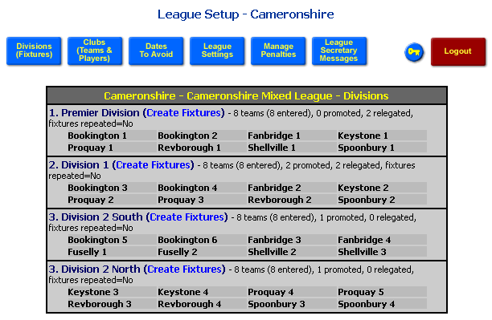
Figure 14 - Create Fixture links are available once all of the teams have been added to the divisions
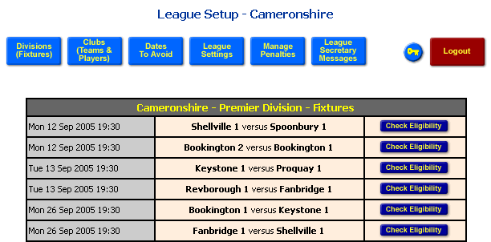
Figure 15 - Automatically created fixtures. Only the first few fixtures are shown
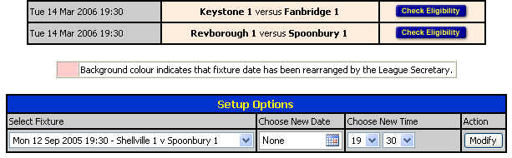
Figure 16 - Last few fixtures plus control panel to edit the fixture date and time if necessary
The fixtures are displayed as a long list in chronological order. At the bottom of the list you there is a control panel that you may use to change the date and time of the fixture if you wish. To do this simply select the fixture from the drop-down list, enter a new date and/or time and then click on the Modify button. This updated fixture will then have a pink background to highlight the fact that it has changed. The club administrators will also see this changed background colour when they log onto the system.
If you return to the Divisions page, by clicking on the ‘Divisions (Fixtures)’ blue button, you will now notice that the links have changed. You can click on the Fixtures link to simply view the fixtures or you can click on the Clear Fixtures link to remove the fixtures. You may wish to remove the fixtures if you need to change a preferred home day for a team or if you need to remove or add a team before the season begins.
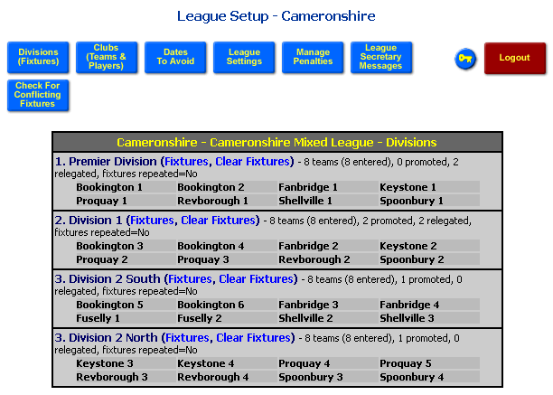
Figure 17 - Fixtures and Clear Fixtures links become available after the fixtures are created

Checking for Fixture Conflicts
The Divisions page also now shows a ‘Check for Conflicting Fixtures’ blue button. Click on this to search for any possible conflicts. This process checks for
- teams from the same club playing in the last n matches of the season (where n is defined on the League Options page),
- too many teams playing at home on the same day with respect to the number of courts that the club has (2 courts are required per fixture), and
- conflicts with special club days such as Valentine’s Day or Bonfire Night
Figure 18 shows the results of the conflict search for our example league. Two conflicts have been found corresponding to Valentine’s Day. As the League Secretary you could now change the date and time of these fixtures. Clicking on the Modify & Recheck button will change the date and time and recheck for conflicts.
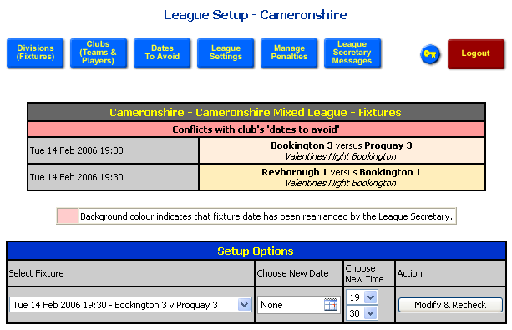
Figure 18 - Fixture conflicts
Please note that you do not need to be logged into NineNil with a password to view the fixtures. You can also view the fixtures by clicking on the blue Fixtures button from the main league page (see Figure 32). From this point you can view fixtures by division, by club or by team.

Running Your League
Chapter
2
What happens during the course of the season?
Throughout the season match score cards must be entered. A number of checks are performed on these score cards to determine whether any league rules have been broken. Normally score cards are entered separately by the home and away Team Captains. Scores can however be added by the Club Administrator and League Secretary. The three different roles have different tasks to complete during the season and these are described in this section.

Team Captains
During the season it is the Team Captain’s role to enter score cards for each home and away game and to add players to the player registration list. Team Captains log on to NineNil from the League main page (See Figure 2) by selecting their team, typing in their password and then clicking on the Login button. Upon logging in the Team Captain will see the page shown below.
If NineNil generated a password for the Team Captain then the first thing the Captain might want to do is change their password to something more personal to them. The password can be changed by clicking on the blue key button and then completing the change password form. Simply type in the old password and the new password, twice for confirmation, and then click on the OK button.
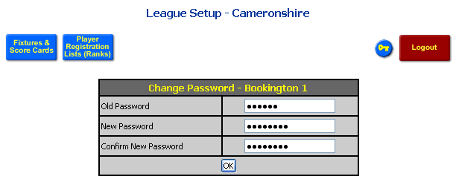
Figure 19 - Change password form
If you forget your password you will need to contact the League Secretary who has access to all passwords.
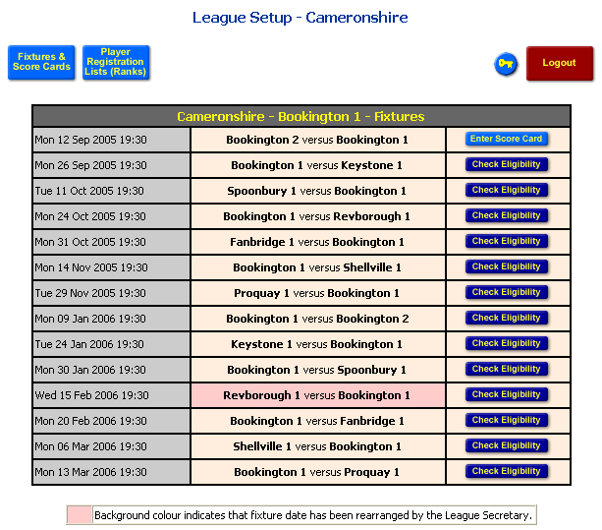
Figure 20 - Team Captain's fixture page
Figure 20 shows a list of fixtures for the Captain’s team. Depending on the current date, each fixture will have a ‘Check Eligibility’ button (for fixtures in the future) or an ‘Enter Score Card’ button for fixtures that have been played. If the score card has been entered already then there will be no buttons available for that fixture.

Entering Scores
To enter a score card, click on the ‘Enter Score Card’ button (Figure 20). This takes you to the score card page shown in Figure 21. In this example we have logged on as the Bookington 1 Team Captain, so we are the away team. An important point to note here is that the home and away teams must each enter the scores. This allows the system to verify the scores. If there are any disagreements between the two scores then the League Secretary is notified and he or she must arbitrate and enter the agreed details. In the example (Figure 21), the lower greyed out card shows that the Home team have not yet entered their details.
You can use the player drop-down list to enter the player who played for each team at each string position. At first the names selected represent the nominated players for each team. If you have replaced any player with a substitute then you must select them from the drop-down lists. You may need to alter the remaining players if this results in a shifting of players up and down the string order. To enter the scores, select the points from the individual game drop-down lists. If a score is invalid (e.g. 10 – 2) for a particular game then an ‘Invalid Score’ message will appear in red. You should then correct the score. A quicker way to enter the scores is to select a drop-down list, type in the number on the keyboard, and then press the Tab key on the keyboard to move to the next drop-down list. To enter a score of 10 in this way, you must press the 1 key twice, which will select the second item in the list beginning with 1 – this is slightly odd but works! If the tie is a walkover then select a W from the points drop-down list for the team to which the walkover is awarded. A walkover might occur when one player fails to play the match or is injured and cannot complete the match.
Once the score have been added you should specify the date on which the fixture was played, using the calendar tool. If the date and all of the scores are entered then the ‘Verify and Enter Scores’ button will become enabled. If it is not enabled, then check that you have entered all of the scores.
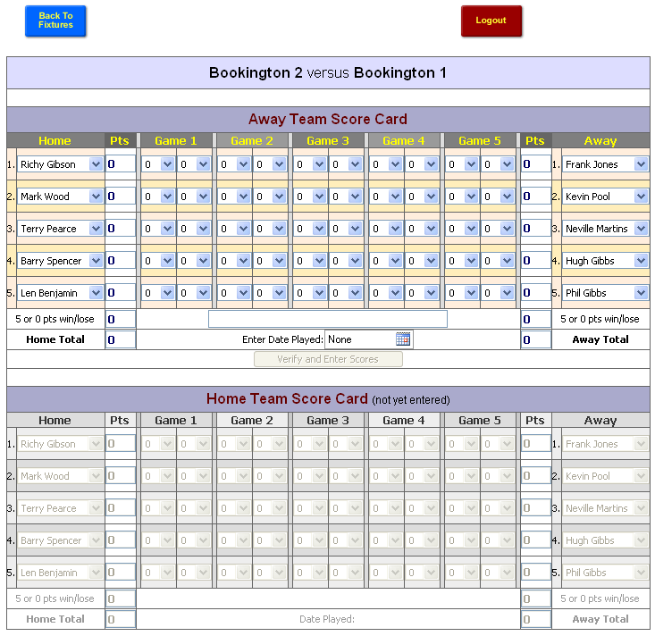
Figure 21 - Score card for Away Team Captain
After clicking on the ‘Verify and Enter Scores’ button, you will be asked to confirm that all of the entries are correct. You will not be able to go back and change the scores after clicking on the OK button.
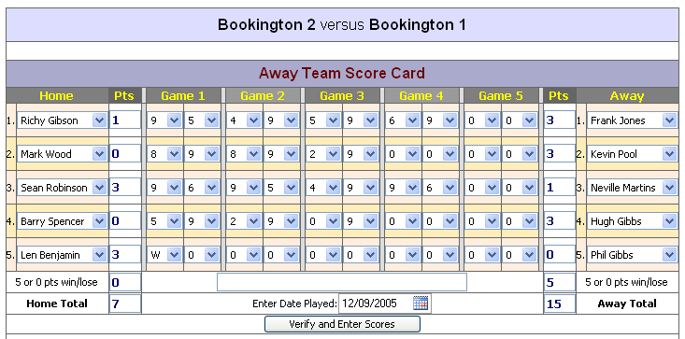
Figure 22 - Completed score card
The home team would then normally enter their version of the score card. When the second Team Captain logs onto to complete the score card they will see that the other team has already entered their version (see Figure 23).
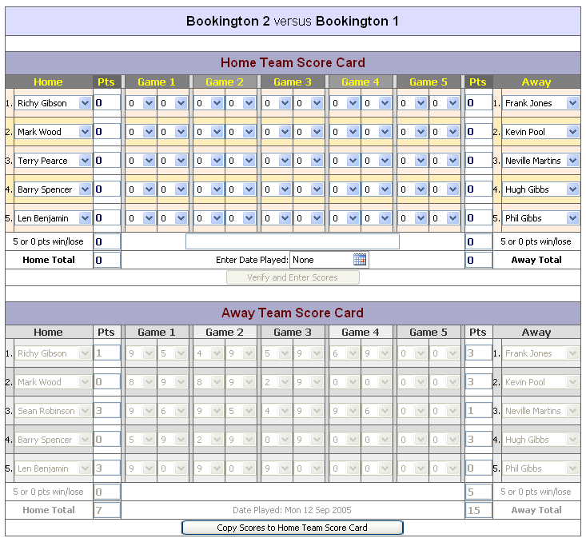
Figure 23 - Score card view when opponents have already entered their score card
As the second Team Captain you can enter you scores as normal or if you agree with the other team’s entries you can click on the ‘Copy Scores…’ button, which will copy all of the scores and player names to your card. You will need to enter the date a usual and then click on the ‘Verify and Enter Scores’ button. Again, you will need to double check and confirm that you wish to enter the scores. At this stage the system will check for any potential errors and penalties that need to be applied. In this case, the system has discovered that the player at String 3 on the home team has played out of order. You will also receive a message that informs you that the scores have been accepted. As both teams are from the same club, you have also been notified that you should send the hand written score card (completed directly after the fixture and signed by both captains) by post to the League Secretary.
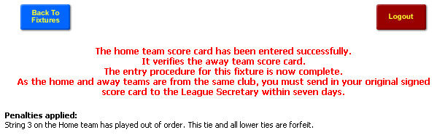
Figure 24 - Penalties applied as a result of entering a score card with a player out of order
Please note that scores are only included in divisional tables when the scores have been verified and agreed by both teams. In the event of a disagreement the scores will not be entered until the League Secretary has judged what the score should be and entered the final scores online.

Checking Player Eligibility
For future matches, as the Team Captain, you can check whether your planned team is likely to incur any penalties. To check eligibility, click on the ‘Check Eligibility’ button on the Fixtures page.
It should be remembered that this is only valid at the time of checking and that if you performed the same check a day later the result might be different. This may be because, in the interim, a player has played a match for a higher team and is now not eligible to play for your team. The figure below shows an example eligibility report.
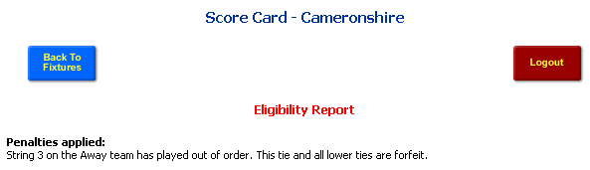
Figure 25 - Eligibility report

Adding Players
Although the Player Registration List of club players is normally maintained by the Club Administrator, each Team Captain can add players to the list. This is allowed so that if a team is short of players, the Captain can add players at short notice before the match is played. Please note that penalties are applied if players are registered after the start of the match.
To add players you should click on the ‘Player Registration Lists (Ranks)’ blue button. You should then add the Players name, select their ranking position and optionally enter their Membership and Phone numbers before clicking on the Add button.
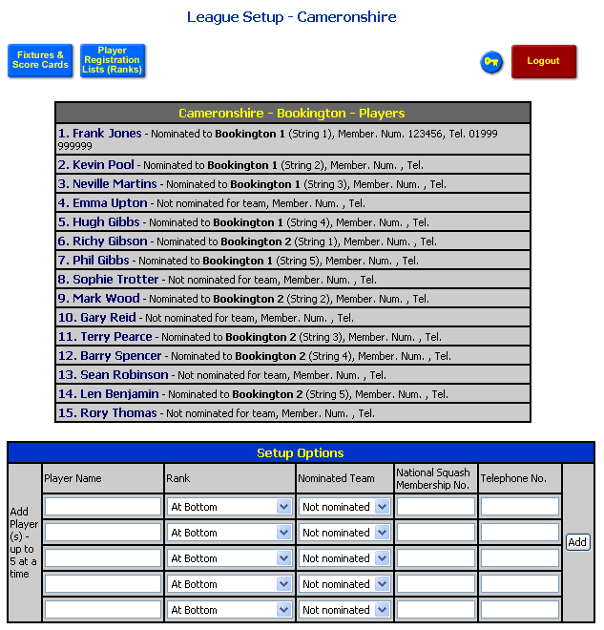
Figure 26 - Adding a player when logged on as the Team Captain

Club Administrator
The Club Administrator’s main role is to maintain the Player Registration List or ranking list for their club. They must also confirm and accept the fixture list on behalf of their club and they can also enter score cards for any of their teams.
When you log on as the Club Administrator, the first page shown is the Player Registration List. Here you can add, remove or modify players’ details as described in Chapter 1. There are certain times during the season when you can change rankings and nominations and you will see a message, displayed in red, describing what you are able to do at that time.
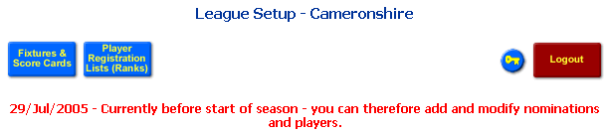
Figure 27 - Message shown to Club Administrator when logged on
Before the season starts you can add and remove players from the list and modify their ranking and nomination to a team. The League Secretary can set up two windows during the season when rankings can be changed and one window when nomination can be changed. At all other times the Club Administrator can only add players.
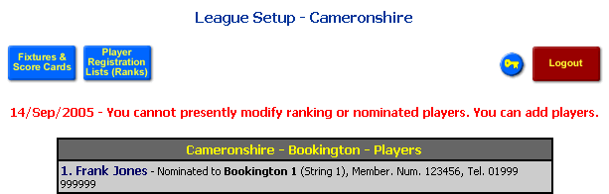
Figure 28 - Normal message shown during the season but outside of the change windows
The other pages available to the Club Administrator can be accessed via the ‘Fixtures & Score Cards’ blue button. From here the Club Administrator can confirm the fixtures, view fixtures, check eligibility of players and enter score cards (see Figure 29).
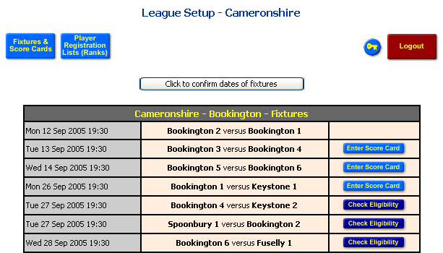
Figure 29 - Club Administrator's fixture page
If the fixtures are still waiting to be confirmed for the season then a button will be shown above the fixture list. You should click on this button when you are happy with your fixture list and do not require any changes. This should be done before the season starts, otherwise penalty points (5 points per week or part week) will be applied to all of the teams in the club.
Scores are entered and eligibility checked in the same way as for Team Captains (see previous section). The only difference is that when a Club Administrator enters the scores for a fixture where both teams are from their club, the score card is automatically verified, i.e. there is no need to enter the score card twice from the home and away perspective.

League Secretary
The League Secretary may also enter score cards and check eligibility. When the League Secretary enters a score card the scores are automatically verified and entered into the results tables. The League Secretary should only need to enter scores when there is a dispute between the home and away recorded scores. If there is a dispute the League Secretary will receive a message describing the dispute.

Messages
To view these messages, click on the ‘League Secretary Messages’ blue button.
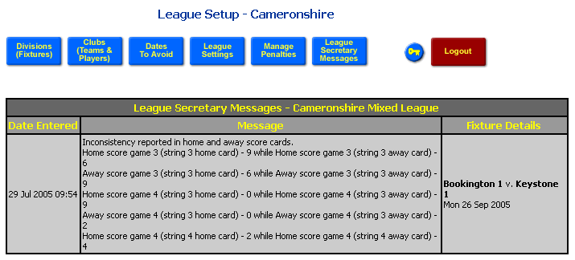
Figure 30 - Messages reported to League Secretary

Penalties
To view, override or add penalties, click on the ‘Manage Penalties’ blue button.
You can use the Manage Penalties page to:
- Override a penalty – click on the Override blue button. The penalty will then be displayed with a pink background and then penalty will not be applied to the results table
- Reapply a penalty that has been overridden previously – click on the ‘Reapply’ red button. The penalty will then be shown with an orange background and the points deduction will be applied to the results table.
- Manually add a penalty. There are two ways to add a penalty, to an individual team or to a club, i.e. all teams within that club. To add the penalty type the description in the appropriate textbox (i.e. upper for teams and lower for clubs), select the number of points from the drop-down list, select the team or club from the appropriate drop-down list and then click on the ‘Add Penalty’ button.
- Delete a previously entered manual penalty – select the penalty from the drop-down list and then click on the ‘Delete Penalty’ button.

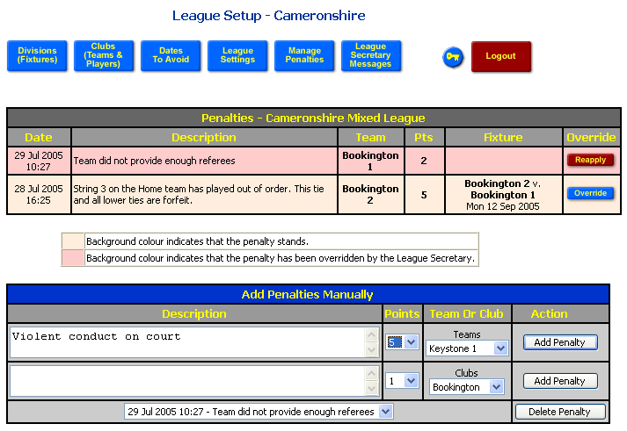
Figure 31 - View, add, override and remove penalties

World View of League
Chapter
3
Viewing fixtures, results, ranking and player statistics.
The remainder of the NineNil system does not require a password to log on and can be viewed by the world at large. NineNil allows the public to view fixtures, verified score cards, divisional tables, ranking lists and player statistics.
To access the world view go to the league access page and then click on the appropriate blue button. Fixtures and tables are available per division while rankings and players statistics are per league.
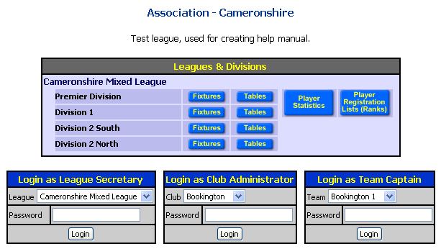
Figure 32 - League access page with world view links

Fixtures and score cards
When you first view the Fixtures page, the Fixtures will be displayed for the associated Division (see above). You can use the Options panel to select fixtures for a different division, a team or home fixtures for a club. The figure below shows the Fixtures for a team. There is a link in the title of the fixtures table that allows you to print out 6 copies of the fixture list which is useful for handing out to the players in the team.
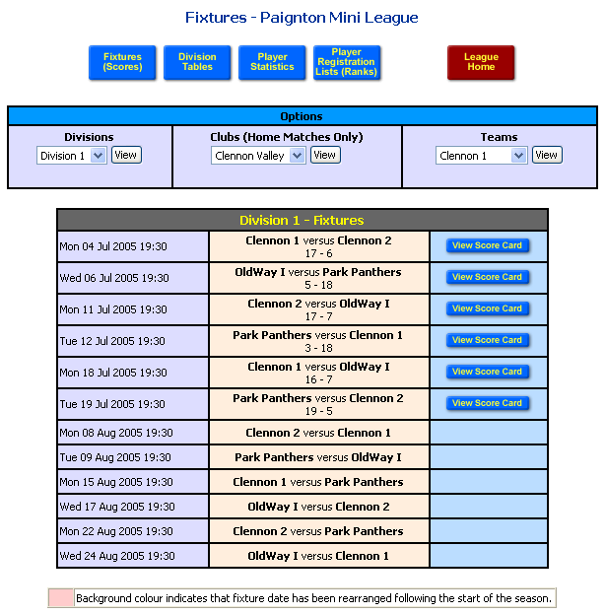
Figure 33 - World view of fixtures per division
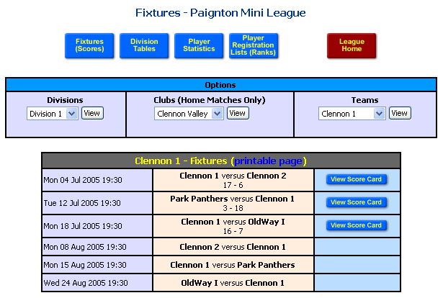
Figure 34 - Team view of fixtures
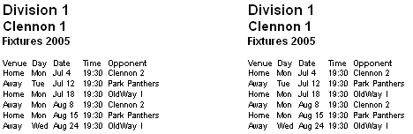
Figure 35 - Printable fixture list
From the fixtures view you can also view the score card for a completed match. Simply click on the ‘View Score Card’ blue button. An example card in shown below.
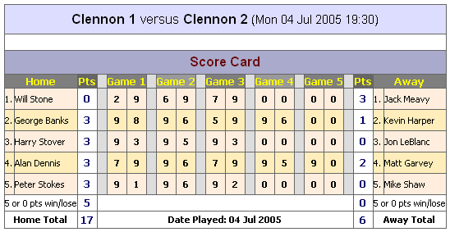
Figure 36 - World view of score card

Division Tables
To view results tables click on the ‘Division Tables’ blue button or click on the appropriate Table blue button on the League access page (Figure 2).
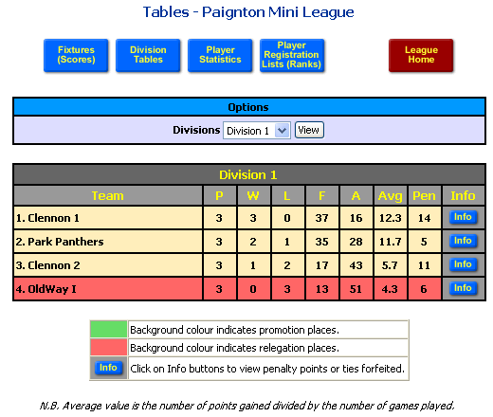
Figure 37 - World view of results tables
The table shown above is for a division of 4 teams. Any teams with a green or red background indicate that they are in the promotion or relegation zones respectively. The ordering in the table is determined by the number of points ‘For’, followed by the number of games won, followed by the inverse of the number of points ‘Against’.
The average value shown in the table is determined by calculating the number of points ‘For’ divided by the number of games played.
You can click on the blue ‘Info’ button to view more information about any penalties that may have been applied to a team (see Figure 38).
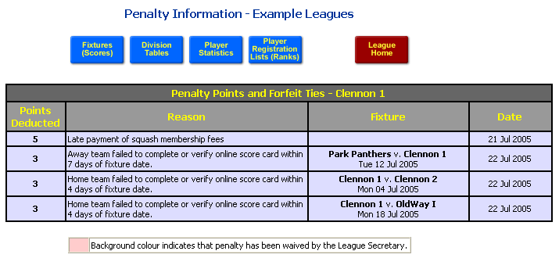
Figure 38 - World view of penalties applied to a team

Player Statistics
To view Player Statistics, click on the blue ‘Player Statistics’ button.
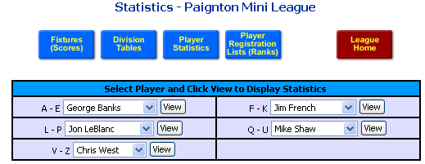
Figure 39 - Player statistics page
When you first view the Player Statistics page you will see a series of drop-down list containing the names of all of the players registered to play in the leagues. The names are sorted alphabetically and are split into five separate list, A-E, F-K, L-P, Q-U and V-Z. To view the statistics for a player, select the players name from one of the drop-down list and then click on the View button next to that list.
The statistics for a player show the results of all of the matches they have played plus a count of the games they have played for each team (e.g. they may have played as a substitute for a higher team). Below the list of match results is a table showing their overall statistics, including number of games played, won etc. The average values in this table is calculated using the difference of points for and points against, divided by the number of games played and plus the number of games won.
The statistics of the chosen player can be compared to others in their team by clicking on the blue ‘Team’ button in the title bar of the table. Similarly, the statistics can be compared to the same string numbers in their division, or all players in their division, club or league by clicking on the appropriate blue button.
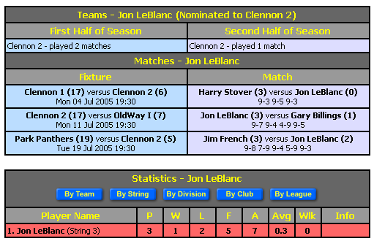
Figure 40 - World view of player statistics
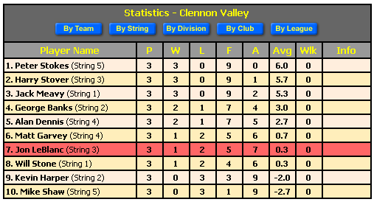
Figure 41 - Comparing Jon LeBlanc's statistics to all the players in his club
Please note that the Team and String buttons are only available for players that are nominated to a particular team.

Player Registration Lists
The Player Registration List can be accessed by clicking on the ‘Player Registration Lists (Ranks)’ blue button. Select a club from the drop-down list and click on the View button.
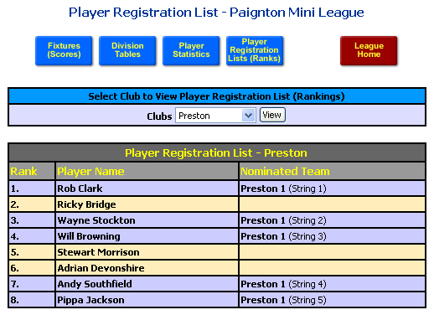
Figure 42 - Ranking list for a club

That’s about it apart from to say ‘enjoy your squash and have a good season’.

This number can be changed by the League Secretary to fit in with league rules (see the League Options section).

